1. List all the **rows** of the table EMP.

Query: select * from emp

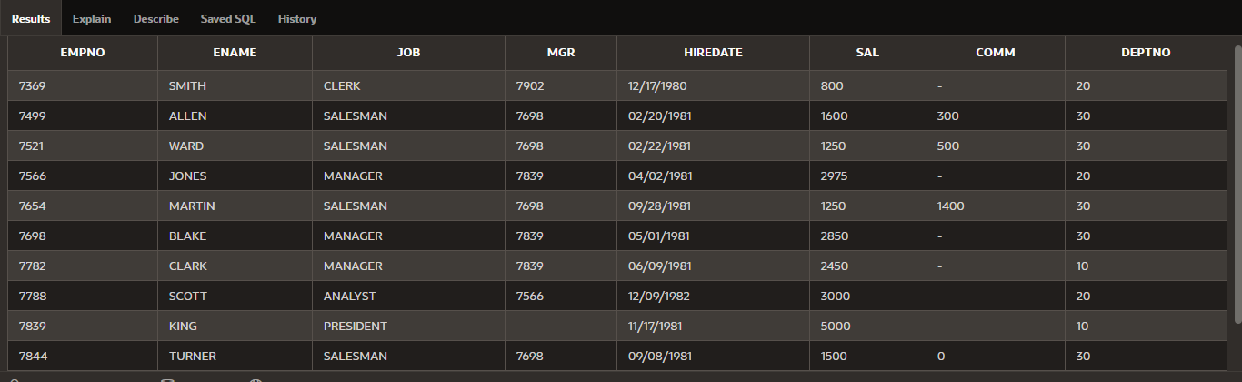

1. List the employees where JOB is CLERK and Salary is greater than 1000

select * from emp

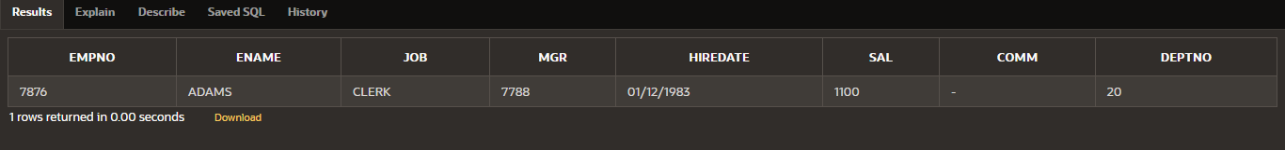where job='CLERK' and sal>1000

1. List the employee’s **employee id and salary.**

select empno,sal from emp

1. List the name and hiredate of employees of department **10**.

select ename,hiredate from emp

where deptno = 10

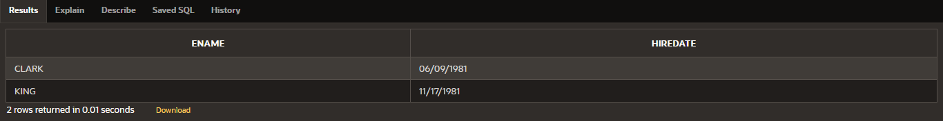

1. List the name and salary of the whole year and name that as **Annual Salary.**

select ename,sal*12 as "Annual Salery" from emp



1. Show the employee who has **1600** salary.

select * from emp

where sal=1600

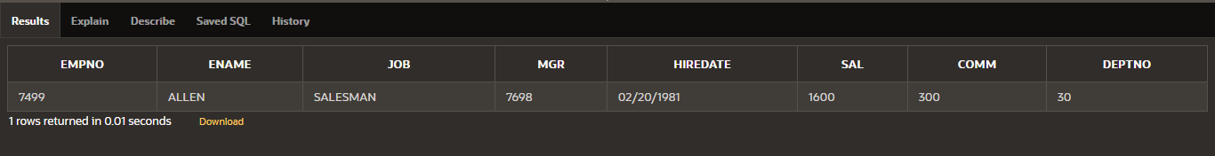

1. List the employees where **salary is greater than 2000.**

select * from emp

where sal>2000

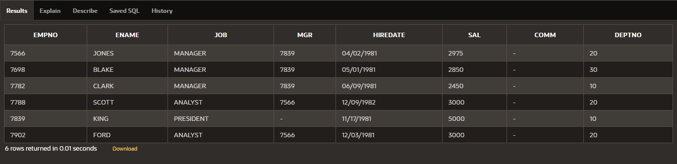

1. List the employees with mgr. no. as **7698.**

select * from emp

where mgr=7698

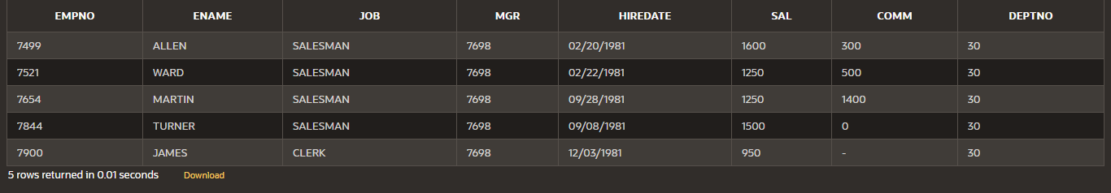

1. Show the record of “**Turner”.**

select * from emp

where ename ='TURNER'

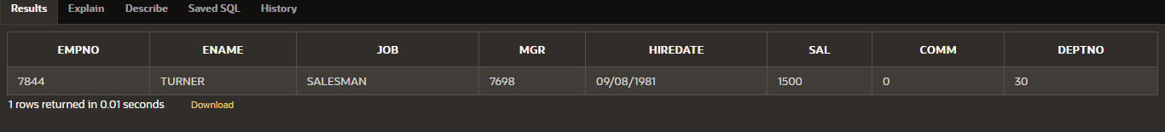

1. List the **President**.

select * from emp

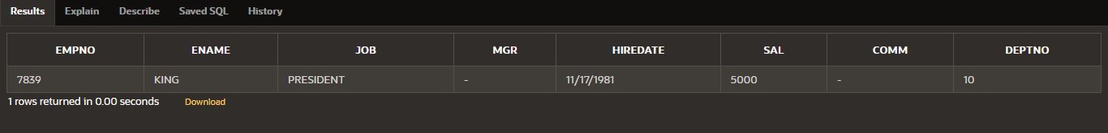where job = 'PRESIDENT'

1. List the employees where department number is **30**.

select * from emp

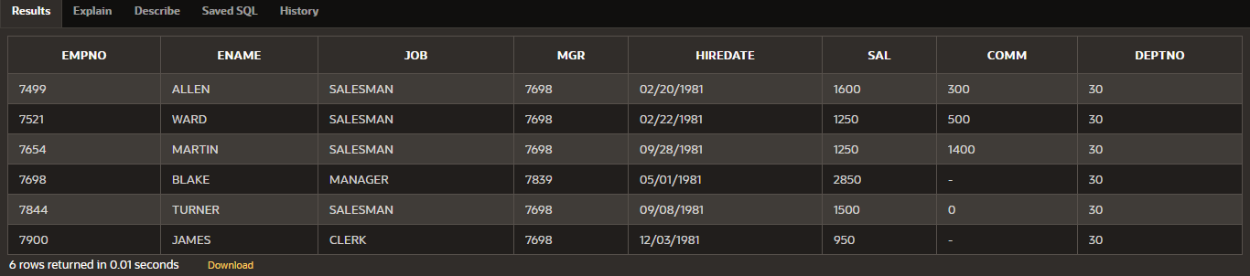where deptno=30

1. List the employees of department **20**.

select * from emp

where deptno=20

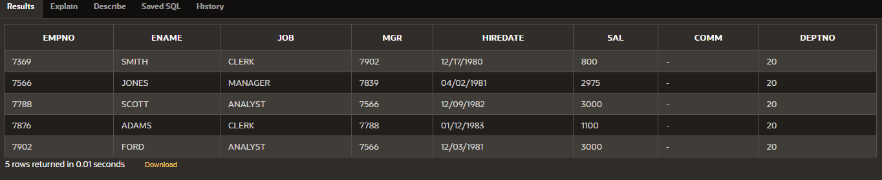

1. List all the employees and add **500** in their salary and name the column as **Bonus**.

select empno,ename,job,mgr,hiredate,sal,sal+500 "BONUS", comm,deptno from emp

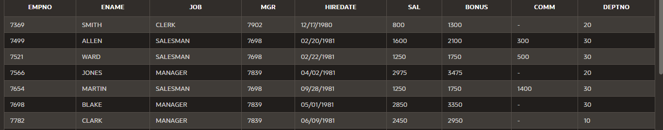

1. List the employees with job title as **‘Analyst’**.

select * from emp

where job='ANALYST'

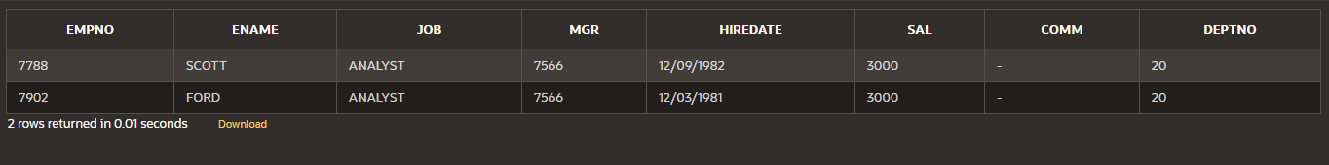

1. Show employee id, name and **total salary=sal+comm**. (NOTE: column name should be “Total Salary”).

select empno,ename, sal+nvl(comm,0) as "Total Salery" from emp

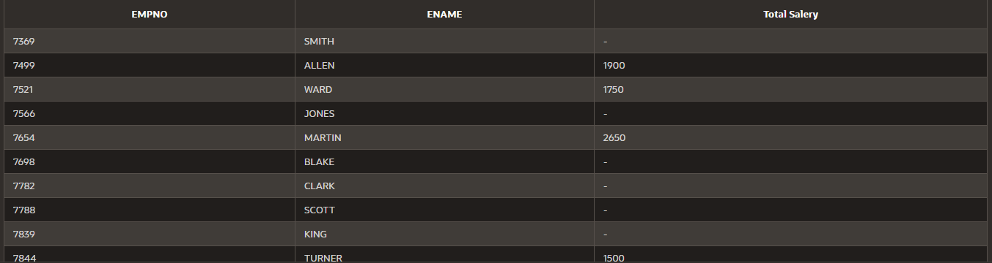

1. Rename the column **hiredate** as job **starting date.**

select empno,ename,job,mgr,hiredate as "Starting Date",sal, comm,deptno from emp

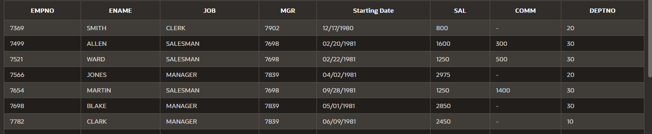

1. Show the record where employee **id=7782.**

select * from emp

where empno=7782



1. Show the records where **mgr=7782.**

select * from emp

where mgr=7782



1. Show the joining date of **Scott**.

select ename, hiredate as "Joining Date" from emp

where ename='SCOTT'

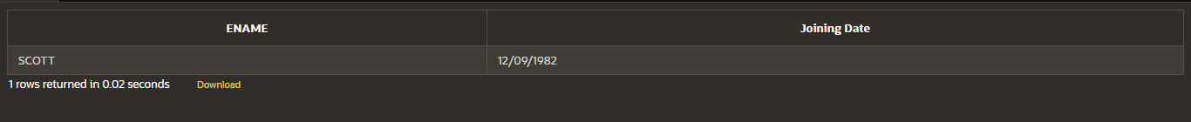

1. Get the **Weekly-salary** of all the employees and name the column as **Weekly Salary**

select empno,ename,job,mgr,hiredate,sal/4 as "Weekly Salary", comm,deptno from emp

